

O'ZBEKISTON RESPUBLIKASI OLIY TA'LIM,FAN VA INNOVATSIYALAR VAZIRLIGI
ABU RAYHON BERUNIY NOMIDAGI URGANCH DAVLAT UNIVERSITETI
WEB TEXNOLOGIYALAR FANIDAN

LABORATORIYA

YO'NALISH: KOMPYUTER ILMLARI VA DASTULASH TEXNOLOGIYASI
GURUH: 234-GURUH, 3-KURS
BAJARDI: IBODULLAYEVA DILAFRUZ
QABUL QILDI: XUSANOV SHIXNAZAR

URGANCH 2025

Labоratоriya ishi №15
Mavzu: : JSON formatda ma’lumotlarni olish va ulash
Maqsad: JSONning web-ishlab chiqish va ma'lumot almashishdagi markaziy rolini hamda ushbu format bilan ishlashning amaliy ko'rinishini berish.
Nazariy qism:
JSON (JavaScript Object Notation) - veb-dasturlashda ma’lumotlarni uzatish uchun eng keng tarqalgan va yengil formatdir. JavaScript bu format bilan juda tabiiy ishlaydi, chunki JSON sintaksisi deyarli to’g’ridan-to’g’ri JavaScript obyektlariga o’xshaydi.
JSON bilan ishlashning ikki asosiy yo’nalishi bor:
- JavaScript Ob’ektini JSON Matniga Aylantirish (Seriyalash/Stringify).
- JSON Matnini JavaScript Ob’ektiga Aylantirish (Deserializatsiya/Parse).
Bu jarayonlar uchun JavaScript’da maxsus global obyekt mavjud: JSON.

1. JavaScript Ob’ektini JSON Matniga O’tkazish (JSON.stringify())
Agar siz JavaScript obyektini veb-servisga yubormoqchi bo’lsangiz yoki uni mahalliy xotirada (localStorage) saqlamoqchi bo’lsangiz, uni JSON matn (string) formatiga aylantirishingiz kerak.
Sintaksis: JSON.stringify(value, replacer, space)

Misol:
javascript
// 1. JavaScript Ob'ekticonst foydalanuvchi = {
id: 101,
ism: "Ali",
familiya: "Valiyev",
ishlaydi: true,
ko'nikmalar: ["HTML", "CSS", "JS"]
};
// 2. JSON matnga aylantirish
const jsonString = JSON.stringify(foydalanuvchi);
console.log(typeof jsonString); // output: "string"
console.log(jsonString); // output: {"id":101,"ism":"Ali","familiya":"Valiyev","ishlaydi":true,"ko'nikmalar":["HTML","CSS","JS"]}

JSON.stringify() ning qo’shimcha parametrlari

a) replacer (Filtr)
Agar siz obyektning faqat ba’zi xususiyatlarini yuborishni istasangiz:
javascript
// Faqat ism va id ni o'tkazishconst jsonFiltr = JSON.stringify(foydalanuvchi, ['id', 'ism']); // output: {"id":101,"ism":"Ali"}

b) space (Formatlash)
JSON matnni o’qish uchun qulayroq qilish (indentatsiya qilish) maqsadida ishlatiladi.
javascript
// 2 ta bo'shliq bilan formatlashconst jsonFormatli = JSON.stringify(foydalanuvchi, null, 2);
console.log(jsonFormatli);/*
output:
{
"id": 101,
"ism": "Ali",
"familiya": "Valiyev",
"ishlaydi": true,
"ko'nikmalar": [
"HTML",
"CSS",
"JS"
]
}
*/

2. JSON Matnini JavaScript Ob’ektiga O’tkazish (JSON.parse())
Serverdan olingan yoki localStorage dan o’qilgan JSON matnni JavaScript’da ishlatish uchun uni obyektga aylantirish kerak.
Sintaksis: JSON.parse(text, reviver)

Misol:
javascript
// 1. Serverdan olingan JSON matn (string)const qabulQilinganJson = '{"mahsulot_nomi":"Noutbuk","narx":1200,"miqdor":1}';
// 2. JavaScript Ob'ektiga aylantirish (parse qilish)const mahsulotObekti = JSON.parse(qabulQilinganJson);
console.log(typeof mahsulotObekti); // output: "object"console.log(mahsulotObekti.mahsulot_nomi); // output: Noutbuk
// Endi u to'liq JavaScript obyekti kabi ishlaydi
mahsulotObekti.narx += 50;console.log(mahsulotObekti.narx); // output: 1250
Eslatma: Agar JSON.parse() ga noto’g’ri formatlangan (sinaksisi buzilgan) matn uzatilsa, u SyntaxError xatini beradi. Shuning uchun uni try...catch blokida ishlatish tavsiya etiladi.
javascript
try {
const notoGriz = JSON.parse("{ism: 'John'}"); // Kalitlar ham string ichida bo'lishi kerak
} catch (e) {
console.error("JSON parse xatosi:", e);
}

3. Fetch API yordamida JSON ma’lumotlarini olish (Server bilan ishlash)
Zamonaviy veb-ilovalar serverdagi API (Application Programming Interface) dan ma’lumotlarni olish uchun Fetch API dan foydalanadi. Ko’pgina API’lar ma’lumotlarni JSON formatida qaytaradi.
Fetch API’da bu jarayon juda osonlashtirilgan:
javascript
// Public API dan foydalanib ma'lumot olishfetch('https://jsonplaceholder.typicode.com/users/1')
.then(response => {
// 1. Javobning JSON ekanligini tekshirish va uni avtomatik parse qilish
// response.json() metodining o'zi JSON.parse() ni bajaradi va Promise qaytaradi
return response.json();
})
.then(data => {
// Bu yerga kelgan 'data' JavaScript Ob'ektidir
console.log("Serverdan olingan ma'lumotlar:");
console.log(`ID: ${data.id}`);
console.log(`Ism: ${data.name}`);
})
.catch(error => {
console.error("Ma'lumot olishda xato yuz berdi:", error);
});

Ma’lumotlarni POST qilish (Yuborish)
Serverga JSON ma’lumotlarini yuborishda, biz JSON.stringify() dan foydalanamiz va so’rovning konfiguratsiyasida Content-Type ni application/json deb ko’rsatamiz:
javascript
const yangiPost = {
title: 'Yangi Post',
body: 'Bu post Fetch orqali yuborildi.',
userId: 5,
};
fetch('https://jsonplaceholder.typicode.com/posts', {
method: 'POST', // Yuborish usuli
headers: {
'Content-Type': 'application/json', // Biz JSON yuboryapmiz
},
body: JSON.stringify(yangiPost) // Ob'ektni JSON stringiga aylantirish
})
.then(response => response.json())
.then(data => {
console.log('Serverdan qaytgan javob (yangi yaratilgan ID):', data.id);
})
.catch(error => console.error('POST xatosi:', error));
Laboratoriyaning amali qismi
1-qadam: Urganch Shahar nomli saytga JSON formatda ma’lumotlarni olish va ulash shu mavzu asosida kod qo’shaman. Index.html kodi:
<!DOCTYPE html>
<html lang="uz">
<head>
<meta charset="UTF-8">
<meta name="viewport" content="width=device-width, initial-scale=1.0">
<title>Urganch shahari – JSON misol</title>
<style>
body {
background-color: #f0f8ff;
font-family: Arial, sans-serif;
text-align: center;
margin: 0;
}

header {
background-color: #0077cc;
color: white;
padding: 30px 0 10px;
}

h1 {
margin: 0;
font-size: 36px;
}

.welcome-text {
font-size: 18px;
color: #e0e0e0;
margin-top: 5px;
}

nav {
background-color: #005fa3;
padding: 10px 0;
}

nav a {
color: white;
text-decoration: none;
margin: 0 15px;
font-size: 18px;
font-weight: bold;
}

nav a:hover {
text-decoration: underline;
}

table {
margin: 20px auto;
border-collapse: collapse;
width: 95%;
}

th, td {
border: 1px solid #dddddd;
padding: 10px;
text-align: left;
}

tr:nth-child(even) {
background-color: #e6f2ff;
}

input {
padding: 8px;
width: 50%;
margin: 15px 0;
font-size: 16px;
}
</style>
</head>
<body>
<header>
<h1>Urganch shahari</h1>
<p class="welcome-text">Xush kelibsiz! JSON orqali ma’lumot olish va filtrlash misoli</p>
</header>

<nav>
<a href="index.html">Bosh sahifa</a>
<a href="tarix.html">Tarix</a>
<a href="galereya.html">Rasm galereyasi</a>
</nav>

<h2>Shahar aholisi jadvali (JSONdan olingan)</h2>
<input id="searchInput" type="text" placeholder="Ism, Familiya yoki Email bo‘yicha qidirish...">

<table>
<thead>
<tr>
<th>Ism</th>
<th>Familiya</th>
<th>Email</th>
</tr>
</thead>
<tbody id="myTable">
<!-- JSON ma’lumot bu yerga qo‘shiladi -->
</tbody>
</table>

<script>
// 60 ta shahar aholisi JSON ma'lumotlari
const users = [
{"ism":"Dilafruz","familiya":"Ibodullayeva","email":"ibodullayeva@gmail.com"},
{"ism":"Dilnoza","familiya":"Yodgorova","email":"dilnoza.yodgorova@example.com"},
{"ism":"Nilufar","familiya":"Karimova","email":"nilufar.karimova@example.com"},
{"ism":"Sardor","familiya":"Axmedov","email":"sardor.axmedov@example.com"},
{"ism":"Aziza","familiya":"Toshpulatova","email":"aziza.toshpulatova@example.com"},
{"ism":"Bekzod","familiya":"Islomov","email":"bekzod.islomov@example.com"},
{"ism":"Shahlo","familiya":"Rustamova","email":"shahlo.rustamova@example.com"},
{"ism":"Jasur","familiya":"Yoqubov","email":"jasur.yoqubov@example.com"},
{"ism":"Gulnora","familiya":"Abdullayeva","email":"gulnora.abdullayeva@example.com"},
{"ism":"Anvar","familiya":"Rahimov","email":"anvar.rahimov@example.com"},
{"ism":"Diyor","familiya":"Xolmatov","email":"diyor.xolmatov@example.com"},
{"ism":"Malika","familiya":"Saidova","email":"malika.saidova@example.com"},
{"ism":"Sardor","familiya":"Eshonov","email":"sardor.eshonov@example.com"},
{"ism":"Zebo","familiya":"Nasriddinova","email":"zebo.nasriddinova@example.com"},
{"ism":"Otabek","familiya":"Rahmatov","email":"otabek.rahmatov@example.com"},
{"ism":"Nilufar","familiya":"Yunusova","email":"nilufar.yunusova@example.com"},
{"ism":"Azim","familiya":"Qodirov","email":"azim.qodirov@example.com"},
{"ism":"Gulbahor","familiya":"Jalilova","email":"gulbahor.jalilova@example.com"},
{"ism":"Shoxrux","familiya":"Toshboyev","email":"shoxrux.toshboyev@example.com"},
{"ism":"Madina","familiya":"Shomurodova","email":"madina.shomurodova@example.com"},
{"ism":"Baxodir","familiya":"Yo‘ldoshev","email":"baxodir.yoldoshev@example.com"},
{"ism":"Nigora","familiya":"Abdullayeva","email":"nigora.abdullayeva@example.com"},
{"ism":"Komil","familiya":"Toshmatov","email":"komil.toshmatov@example.com"},
{"ism":"Dilshod","familiya":"Rahimov","email":"dilshod.rahimov@example.com"},
{"ism":"Gulnoza","familiya":"Xolmurodova","email":"gulnoza.xolmurodova@example.com"},
{"ism":"Javohir","familiya":"Karimov","email":"javohir.karimov@example.com"},
{"ism":"Sevara","familiya":"Azimova","email":"sevara.azimova@example.com"},
{"ism":"Ulug‘bek","familiya":"Yo‘ldoshev","email":"ulugbek.yoldoshev@example.com"},
{"ism":"Nilufar","familiya":"Sodiqova","email":"nilufar.sodiqova@example.com"},
{"ism":"Shaxlo","familiya":"Raximova","email":"shaxlo.raximova@example.com"},
{"ism":"Bobur","familiya":"To‘xtayev","email":"bobur.toxtayev@example.com"},
{"ism":"Gulchehra","familiya":"Shamsiddinova","email":"gulchehra.shamsiddinova@example.com"},
{"ism":"Oybek","familiya":"Qodirov","email":"oybek.qodirov@example.com"},
{"ism":"Nigina","familiya":"Samatova","email":"nigina.samatova@example.com"},
{"ism":"Shahzoda","familiya":"Abdullaeva","email":"shahzoda.abdullaeva@example.com"},
{"ism":"Azamat","familiya":"Toshmatov","email":"azamat.toshmatov@example.com"},
{"ism":"Malik","familiya":"Rahimov","email":"malik.rahimov@example.com"},
{"ism":"Gulruh","familiya":"Saidova","email":"gulruh.saidova@example.com"},
{"ism":"Davron","familiya":"Xolmatov","email":"davron.xolmatov@example.com"},
{"ism":"Saodat","familiya":"Yo‘ldosheva","email":"saodat.yoldosheva@example.com"},
{"ism":"Olim","familiya":"Rahmonov","email":"olim.rahmonov@example.com"},
{"ism":"Zilola","familiya":"Toshpulatova","email":"zilola.toshpulatova@example.com"},
{"ism":"Sherzod","familiya":"Abdullayev","email":"sherzod.abdullayev@example.com"},
{"ism":"Gulnisa","familiya":"Shokirova","email":"gulnisa.shokirova@example.com"},
{"ism":"Ibrohim","familiya":"Yo‘ldoshev","email":"ibrohim.yoldoshev@example.com"},
{"ism":"Shahnoza","familiya":"Qodirova","email":"shahnoza.qodirova@example.com"},
{"ism":"Farruh","familiya":"Karimov","email":"farruh.karimov@example.com"},
{"ism":"Nigora","familiya":"Abdullayeva","email":"nigora.abdullayeva2@example.com"},
{"ism":"Bekzod","familiya":"Toshmatov","email":"bekzod.toshmatov@example.com"},
{"ism":"Malika","familiya":"Rahmatova","email":"malika.rahmatova@example.com"},
{"ism":"Shoxrux","familiya":"Yo‘ldoshev","email":"shoxrux.yoldoshev@example.com"},
{"ism":"Gulnoza","familiya":"Xolmatova","email":"gulnoza.xolmatova@example.com"},
{"ism":"Jasur","familiya":"Abdullayev","email":"jasur.abdullayev@example.com"},
{"ism":"Nilufar","familiya":"Rahimova","email":"nilufar.rahimova2@example.com"},
{"ism":"Aziza","familiya":"Toshmatova","email":"aziza.toshmatova@example.com"},
{"ism":"Diyor","familiya":"Xolmatov","email":"diyor.xolmatov2@example.com"},
{"ism":"Madina","familiya":"Shomurodova","email":"madina.shomurodova2@example.com"},
{"ism":"Baxodir","familiya":"Yo‘ldoshev","email":"baxodir.yoldoshev2@example.com"},
{"ism":"Gulbahor","familiya":"Jalilova","email":"gulbahor.jalilova2@example.com"}
];

// Jadvalga ma’lumotlarni qo‘shish
const tableBody = document.getElementById("myTable");
users.forEach(user => {
const row = document.createElement("tr");
row.innerHTML = `<td>${user.ism}</td><td>${user.familiya}</td><td>${user.email}</td>`;
tableBody.appendChild(row);
});

// Qidiruv funksiyasi
document.getElementById("searchInput").addEventListener("keyup", function() {
const value = this.value.toLowerCase();
const rows = tableBody.getElementsByTagName("tr");
Array.from(rows).forEach(row => {
const text = row.textContent.toLowerCase();
row.style.display = text.indexOf(value) > -1 ? "" : "none";

});
});
</script>
</body>
</html>

2-qadam: Kod natijasi:
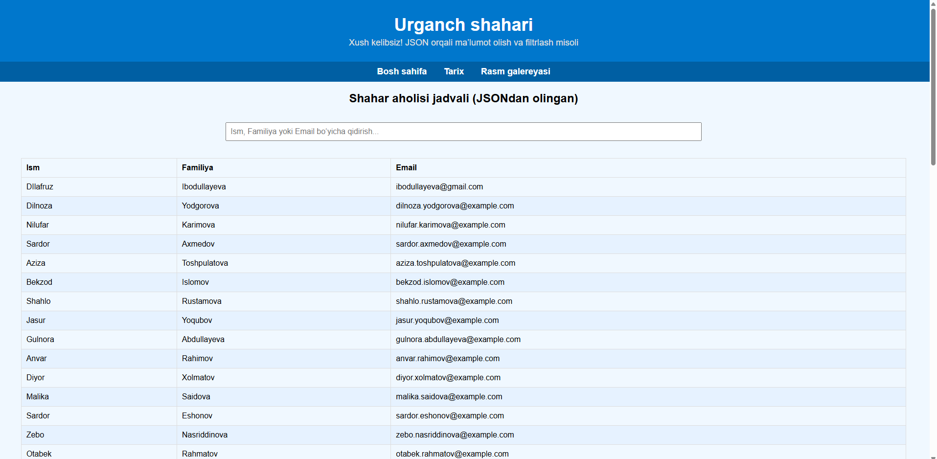
Qidirganda:
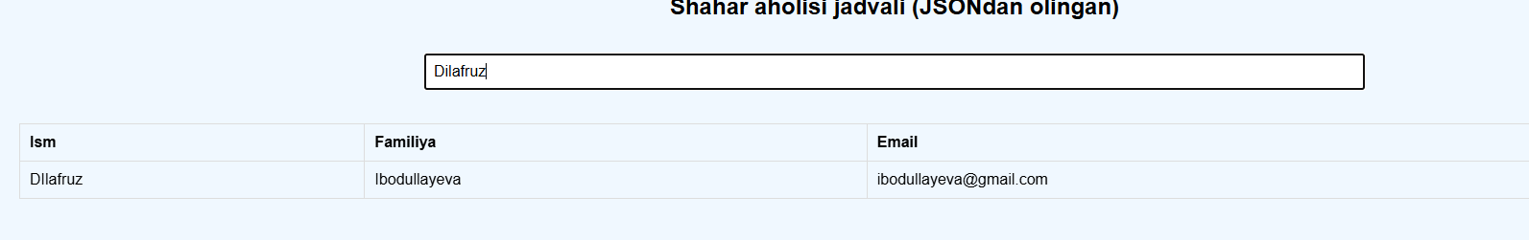
Xulosa
Ushbu ish davomida JSON (JavaScript Object Notation) formati orqali ma’lumotlarni saqlash, uzatish va web sahifada ko‘rsatish bo‘yicha nazariy va amaliy ko‘nikmalar hosil qilindi.
- Nazariy jihatdan:
  - JSON – engil, inson o‘qishi oson va dasturiy tillarga mos format ekanligi tasdiqlandi.
  - Ma’lumotlar kalit-qiymat (key-value) juftliklari orqali strukturalangan va massivlar, obyektlar, nested strukturalarni qo‘llab-quvvatlaydi.
  - JSON platformaga bog‘liq emas va web hamda mobil dasturlarda keng qo‘llaniladi.
- Amaliy jihatdan:
  - HTML sahifaga 60 ta shahar aholisi ma’lumotlarini JSON orqali kiritish va jadvalga chiqarish amalga oshirildi.
  - Qidiruv funksiyasi yordamida foydalanuvchi ism, familiya yoki email bo‘yicha ma’lumotlarni filtrlash imkoniyati yaratildi.
  - Bu jarayon JSON bilan ishlashning soddaligi va samaradorligini ko‘rsatadi.
- Foyda va xulosalar:
  - JSON yordamida ma’lumotlarni web sahifaga dinamik tarzda kiritish oson.
  - Jadval va qidiruv funksiyasi orqali foydalanuvchi qulay ishlash imkoniga ega bo‘ladi.
  - Ushbu misol real dasturlash amaliyoti uchun yaxshi asos bo‘lib, kelajakda AJAX yoki fetch API orqali serverdan ma’lumot olishga oson o‘tish imkonini beradi.
Yakuniy xulosa: JSON – zamonaviy web va mobil dasturlarda ma’lumot almashishning asosiy formati bo‘lib, uning qulayligi, platformaga mustaqilligi va strukturalangan tuzilishi dasturchilarga katta imkoniyatlar yaratadi. Amaliy misol orqali esa, foydalanuvchi ma’lumotlarni dinamik ravishda filtrlash va ko‘rish imkoniga ega bo‘ldi.

